April 28, 2024
Supplies Needed:
Construction paper (1 per kid)
Cotton balls (2 per kid)
Blue markers
Glue sticks
Gideon’s Fleece Activity page provided (1 per kid)
Bucket or bin for optional variation of shoe game

Suggested Schedule:
5 minutes - Pick up kids/kids arrive - bathroom, wash hands, water break
20 minutes - Snack, Games, Prayer/Devotion, Quality Time, Clean-up
30-40 minutes - RBKids Lesson & Prayer
10-15 minutes - Free time, Clean-up and Dismissal

Today’s Focus:
God will help us grow our faith.

Weekly Verse:
“The earth is the Lord’s, and everything in it, the world, and all who live in it.” Psalm 24:1 (NIV)

Key passage:
Judges 6:33-40, Gideon

Rock Bridge Mission:
We are kingdom seekers, like Gideon we want to seek God and wait on God and be obedient to what God is asking us to do.

Prayer:
Dear God, Be patient with us and help us grow our faith! In Jesus’ name, Amen
Introduction:
Do This As Kids Arrive: What is your favorite mystery story? (You can ask if they know Scooby Doo, Nancy Drew, the Boxcar Children, Encyclopedia Brown, Cam Jansen, and the Three Investigators.)

Say this: Do you have any idea how many clues detectives find in clothes at a crime scene? Checking the clothes of a crime victim can lead to all sorts of information. Their phone can tell us the last person they called, the last person they texted, any maps they might have used, and Google searches they might have made. Any evidence to help them form some theory as to what happened. Gideon wanted some evidence that God was really with him. God could have taken offense at this, but He shows us how patient He can be in today’s story. God wants us to trust Him. He is willing to take the time to earn our trust, and He will never give up on us. The fleece that was wet and then dry gave Gideon all the faith he needed to lead Israel to an astonishing victory. God is patiently waiting on all of us to give Him our trust. He is not put off by our questions. He is not going to walk away in frustration. If we seek answers, He will give them. He will do what He must to grow our faith!
Say this: In the real world criminal justice system, it takes a great deal of evidence to convict someone of a crime. Why? Because we do not want to send an innocent person to jail. Most people would agree it’s better to let ten guilty people go free than to let one innocent person go to jail for a crime they did not commit. Police and prosecutors are as meticulous as possible collecting physical evidence, interviewing witnesses, and gathering as much information as they can to not just solve the crime, but convince a jury that the suspect is indeed guilty. The final test of the police investigation usually happens in a courtroom where a jury of twelve men and women will determine guilt or innocence. It’s up to the prosecution to convince those twelve people that there’s enough evidence to send the suspect to jail. Once all the evidence is presented, the judge tells the jury that if they believe, beyond all reasonable doubt, that the suspect is guilty, they should vote guilty. If, however, there are reasons to doubt the case, they should err on the side of caution and say innocent. That phrase, “beyond all reasonable doubt,” means the prosecutors asking for a guilty verdict have the harder job. The defense attorney, whose job it is to defend the suspect, only has to find one flaw in the case to create enough doubt to convict their client. In our world, there is plenty of evidence that the Bible is true. Archaeologists are always finding evidence of the ancient Biblical stories and the people written about in the Bible. But there’s also reason for doubt. Where is the physical evidence of God’s great miracles? Why don’t we see these great miracles today? Why doesn’t God speak openly to people like He did in the Bible? How do we know Jesus was real if there is no physical evidence? Believing in God takes faith.
Read: Judges 6:33-40, Gideon
Talk About This: Israel was in trouble, and God had a plan to save them. God needed Gideon to lead Israel into battle against the Midianites, but Gideon needed some convincing. Gideon wanted to know, beyond a reasonable doubt, that it was God speaking to him. He asked God to do a miracle, and God did just as he asked. Then Gideon asked God to reverse that miracle, just so he could know without a doubt this was for real. God was patient with Gideon, and He gave him that second miracle. God wants us to have faith to begin our journey with Him, but He’s not afraid of our testing Him. He will be patient with us because more than anything, He wants us to love Him as He loves us!
Discussion questions:
ask This: Gideon needed extra assurance from God but God still showed incredible patience with Gideon, but doesn’t He still do the same for all of us?

- What did God ask Gideon to do?
- Why did Gideon test God?
- Why was God patient with Gideon?
- Will God be patient with us?
- How can this story help us grow our faith in God?

Drive it home - Say this: I’m sure you’ve all seen the grass in your yard wet with dew, and if you have, you know that anything left out overnight will be wet too. Gideon asked for a pretty difficult miracle. He wanted the fleece covered in dew and the ground dry. Then he asked God to reverse the sign: make the ground wet and the fleece dry. It’s another miracle we can’t explain, one that we can only chalk up to the power of God. But it took both signs to convince Gideon, beyond all reasonable doubt, that God was with him and ready to make him a hero. One of the big questions doubters like to throw at us is why God doesn’t do miracles like these any more. Why won’t He cure cancer for a faithful believer? Why won’t he bring an end to homelessness, or war, or famine? If God parted the waters of the sea and sent fire from Heaven in ancient times, why doesn’t He do miracles now? It takes more than physical evidence in a court of law to convict someone of a crime. It takes testimony from witnesses, from experts, and others to give that evidence meaning. We have in the Bible the eyewitness testimony of those who saw these things. We have the life-changing stories of men like Gideon to help us believe. What’s more, we have the testimony of people living today, people in our own church, who have given their heart to God. No, they’ve never seen Him. Maybe they’ve never seen a miracle like the two Gideon saw. But they have witnessed enough to believe beyond a reasonable doubt that God is not only real, but that He loves them.

Activity:
Do this: Give everyone a piece of construction paper, fold paper in half (horizontally) and glue the papers that say the first night and the second night on the bottom of each side. Have them glue cotton balls onto each side. Then they will use a marker to put blue dots on the cotton ball on the side that the water was on the fleece and put blue dots around the cotton balls on the other side. (See example below)
Example Picture:
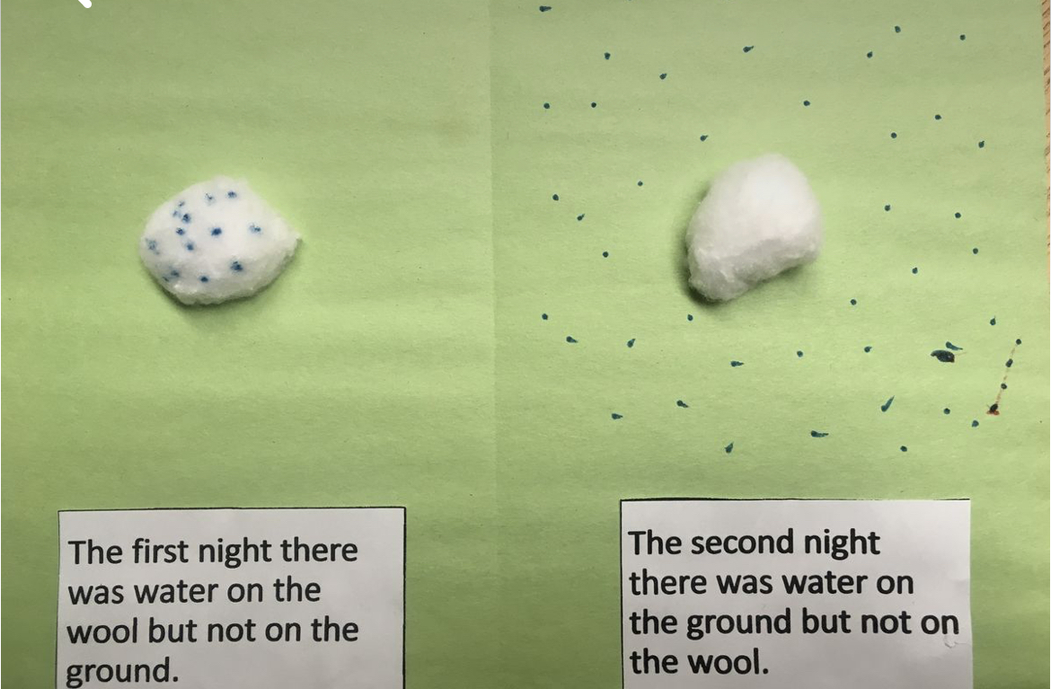

Say this: God showed incredible patience with Gideon, but doesn’t He still do the same for all of us? Thank God for his patience with you this week. Let’s take a moment to pray for God to grow our faith and to ask God to continue being patient with us. (Take a few minutes to “popcorn pray,” you start and ask one kid to close the time and whoever would like to pray in between can.)

Memory Verse Activity:
“The earth is the Lord’s, and everything in it, the world, and all who live in it.” Psalm 24:1 (NIV)

Do this: Play the telephone game, start with the verse, and see how mixed up it gets by the end. Play several rounds with the verse and then have several of the kids choose an appropriate phrase and share it around the circle.

Say this: We memorize this scripture to remind us that everything on the earth is the Lord’s and so are we!

Optional Activity:
do this: Split the room in half, and have both groups stand in a circle. Have everyone take off their left shoe and throw it into a pile in the middle of the circle. Have an adult leader “stir” the shoes, then have the kids race to try and find their shoes. The first group to have everyone find and put their shoes back on wins. **If you don’t want to do shoes, have kids initial a piece of paper, toss them in a pile and find the owner!)

try this: Collect all the shoes in a bucket, then pass the bucket around and let each kid grab a shoe at random. The kids will have to find the other kid whose shoe they have and return it to them. First team to give everyone their shoe back wins.

say this: It takes patience to win this game. This reminds us that God will be patient with us as he grows our faith.

do this: True or False Review:
God asked Gideon to build an ark.
FALSE

As soon as God finished speaking, Gideon went to work doing as God asked.
FALSE

Gideon tested God twice.
TRUE

When Gideon asked for his second test, God said no.
FALSE

God will be patient with us as we build our faith.
TRUE

